**Profile No.: 88 NIC Code: 29201**

**AUTO PISTONS AND PISTON RINGS**

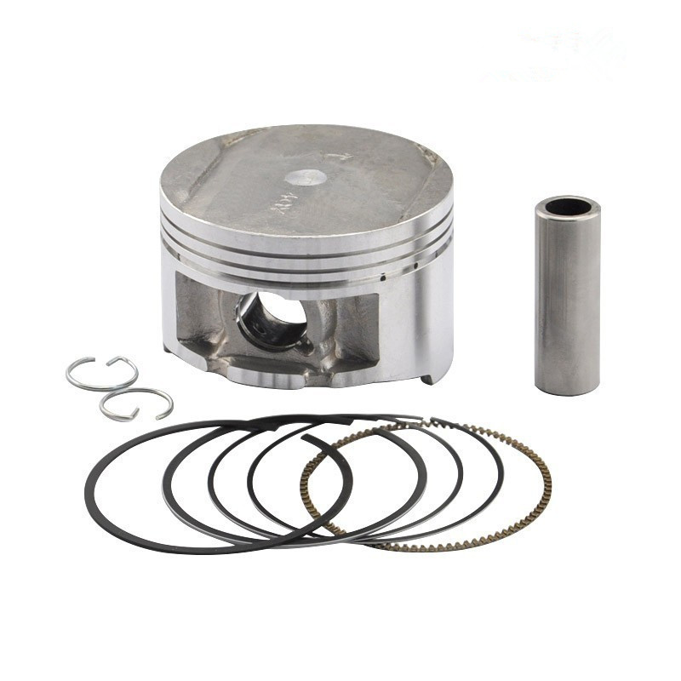

**1. INTRODUCTION:**

Pistons of majority auto vehicles are no made of aluminum and produced by Gravity casting of Aluminium alloy. They are also made from cast iron and steel alloys for heavy duty vehicles and large capacity generator or marine engines. Piston Rings are used as gas sealing element on piston. They are normally made of cast iron alloys due to better wear and lubricating properties and better oil film retention properties.

**2. PRODUCT & ITS APPLICATION:**

Auto piston is a part of automobile which reciprocates in the engine cylinder to transmit power to the wheels. A piston is a component of reciprocating engines, reciprocating pumps, gas compressors and hydraulic and pneumatic cylinders, among other similar mechanisms use pistons and piston rings. It is the moving component that is contained by a cylinder and is made gas-tight by piston rings. In an engine, its purpose is to transfer force from expanding gas in the cylinder to the crankshaft via a piston rod and/or connecting rod. In a compressor or pump, the function is reversed to pressurize or eject gas or fluid.

Pistons and rings are used in automobile industries and auto vehicles in huge quantity and the OE manufacturers and replacement trade are its main customers.

**3. DESIRED QUALIFICATIONS FOR PROMOTER:**

The promoter with experience in automobile component production and technical knowledge of alloying and piston and ring geometry achievement through machining and knowledge of heat treatment and having mechanical / metallurgical engineering background will be able to manage the project well.

**4.** **INDUSTRY OUTLOOK/TREND**

Asia is expected to emerge as the largest market due to increasing vehicle production and demand, growing vehicle population, improvement in the economic conditions, and increasing investments by the industry players within the APAC region. North America and Asia Pacific are expected to witness significant growth over the next decade because of rapidly increasing demand of filters in OEMs as well as the replacement or aftermarkets.

The auto-component industry of India has expanded by 14.3 per cent because of strong growth in the spares or after-market sales to reach at a level of Rs 2.92 lakh crore (US$ 44.90 billion) in the year 2017. The auto-components industry accounts for almost seven per cent of India’s Gross Domestic Product (GDP) and employs as many as 25 million people, both directly and indirectly.

At present, there are more than 30 manufacturers in large and small medium sector of various types of pistons and ring set manufacturers for 2, 3 and 4 wheel vehicle engines, off road and earth moving machines and standby power generating sets. The unit clusters are mainly located in North Indian centers like Punjab, Haryana, Delhi and West UP, in Maharashtra around Pune and Bombay and Southern India near Bangalore, Chennai and Hyderabad, in Gujarat around Rajkot and Surendranagar.

**5. MARKET POTENTIAL AND MARKETING ISSUES. IF ANY:**

India’s passenger vehicles of around 29 million during 2015 are expected to grow to more than 48 million vehicles by 2020. With the increasing automobile demand, the country is also proportionately expected to witness a surge in replacement components for these vehicles.

Apart from automobiles, air and gas compressors mining equipment, trucks, buses, trains, generator sets, forklifts and other types of engine require pistons and rings. The demand is expected to expand at an average growth rate of 15%. The replacement market is also likely to expand. There also exists good demand for export of quality products for replacement markets overseas.

**6. RAW MATERIAL REQUIREMENTS:**

Auto pistons are made of alloy aluminum and these alloys are required in ingot form. Al. Alloys for I.C. Engine Pistons, basically four grades of the alloys have been specified by IS 7793 namely 2285, 4658, 4928 - A and 4928 - B with various alloying compositions like Cu, Mg, Si, Fe, Mn, Ni, Zinc etc. are required. Hardness has been specified between 90 to 140 HB with tensile strength ranging from 165 to 275 N/mm2 for various grades.

Piston rings and diesel engine pistons require pig iron/ cast iron and steel scrap. The preferred material for compression rings is a low-alloyed, heat-treated nodular cast iron that is achieved in melt while casting. Various alloying additives for elements like molybdenum, chromium, silicon, manganese etc. are required for achieving desired alloy compositions.

**7. MANUFACTURING PROCESS:**

Aluminum pistons are used for most passenger vehicles like two, three and four wheelers. Though heavy duty engines like diesel engines use forged and cast steel piston. For automotive applications, Pistons and rings must have performance properties and durability. These are essentially obtained through heat treatment and proper geometry profile for piston crowns as well as piston rings.

The piston material has to be chosen closer to its operating temperature limits and designed to improve the thermal management. New, high performance aluminum alloys and coatings, with good casting technology and machining and give desired performance.

Piston rings materials require high bending strength and modulus of elasticity, and increased hardness of 320 to 470 HB is produced in order to obtain the required wear resistance in the uncoated condition. The demand for high wear strength is met by the use of a tempered, alloyed cast iron. The good wear resistance results from the combination of a fine pearlitic matrix structure and finely dispersed, precipitated secondary carbides.

It is, therefore, essential that the proper alloy selection, casting techniques, surface heat treatment and machining with close tolerances are achieved for optimum product quality with minimum cost.

Gravity Die Casting as well as sand mold casting is suggested for casting of pistons and rings. The melting and holding furnaces give desired alloys that are cast and thereafter cast components are machined with attachments and tooling on lathes/ milling drilling machines to get desired profiles and size. These components are then heat treated, machined for surface properties. The grinding and lapping after heat treatment and coating gives finished product.

**8. MANPOWER REQUIREMENT:**

The unit shall require highly skilled service persons. The unit can start from 20 employees initially and increase to 52 or more depending on business volume.

|  |  |  |  |  |  |  |  |
| --- | --- | --- | --- | --- | --- | --- | --- |
| **Sr. No.** | **Type of Employees** | **Monthly Salary** | **No of Employees** | | | | |
| **Year 1** | **Year 2** | **Year 3** | **Year 4** | **Year 5** |
|  | Skilled Operators | 18000 | 8 | 12 | 16 | 18 | 20 |
|  | Semi-Skilled/ Helpers | 9000 | 8 | 12 | 16 | 18 | 24 |
|  | Supervisor/ Manager | 25000 | 1 | 2 | 2 | 3 | 3 |
|  | Accounts/ Marketing | 18000 | 1 | 1 | 3 | 3 | 3 |
|  | Other Staff | 8000 | 2 | 2 | 2 | 2 | 2 |
|  | TOTAL |  | 20 | 29 | 39 | 44 | 52 |

**9. IMPLEMENTATION SCHEDULE:**

The unit can be implemented within 7 months from the serious initiation of project work.

The unit is based on selection of location, renting premises for the unit.

|  |  |  |
| --- | --- | --- |
| **Sr. No.** | **Activities** | **Time Required in Months** |
| 1 | Acquisition of Premises | 1 |
| 2 | Construction (if Applicable) | 2 |
| 3 | Procurement and Installation of Plant and Machinery | 3 |
| 4 | Arrangement of Finance | 2 |
| 5 | Manpower Recruitment and start up | 2 |
|  | Total Time Required (Some Activities run concurrently) | 7 |

**10. COST OF PROJECT:**

The unit will require total project cost of Rs 162.50 lakhs as shown below:

|  |  |  |
| --- | --- | --- |
| **Sr. No.** | **Particulars** | **In Lakhs** |
| 1 | Land | 25.00 |
| 2 | Building | 45.00 |
| 3 | Plant and Machinery | 58.35 |
| 4 | Fixtures and Electrical Installation | 4.05 |
| 5 | Other Assets/ Preliminary and Preoperative Expenses | 2.50 |
| 6 | Margin for working Capital | 27.60 |
|  | **TOTAL PROJECT COST** | **162.50** |

**11. MEANS OF FINANCE:**

The project will require promoter to invest about Rs 61.33 lakhs and seek bank loans of Rs 101.18 lakhs based on 70% loan on fixed assets.

|  |  |  |
| --- | --- | --- |
| **Sr. No.** | **Particulars** | **In Lakhs** |
| 1 | Promoters Contribution | 61.33 |
| 2 | Loan Finance | 101.18 |
|  | TOTAL : | 162.50 |

**12. WORKING CAPITAL REQUIREMENTS:**

Working capital requirements are calculated as below:

(Rs. Lakh)

|  |  |  |  |  |  |
| --- | --- | --- | --- | --- | --- |
| **Sr. No.** | **Particulars** | **Gross Amount** | **Margin %** | **Margin Amount** | **Bank Finance** |
| 1 | Inventories | 16.02 | 40 | 6.41 | 9.61 |
| 2 | Receivables | 23.04 | 50 | 11.52 | 11.52 |
| 3 | Overheads | 3.26 | 100 | 3.26 | 0.00 |
| 4 | Creditors | 16.02 | 40 | 6.41 | 9.61 |
|  | TOTAL | 58.35 |  | 27.60 | 30.75 |

**13. LIST OF MACHINERY REQUIRED:**

|  |  |  |  |  |  |
| --- | --- | --- | --- | --- | --- |
| **Sr. No.** | **Particulars** | **UOM** | **Quantity** | **Rate** | **Total Value** |
|  | Main Machines/ Equipment |  |  |  |  |
| 1 | Melting Furnace for Al Alloy and steel/ cast iron alloys | Nos. | 3 | 250000 | 750000 |
| 2 | Gravity/ low pressure Die casting machine 1kg / shot | Nos. | 1 | 650000 | 650000 |
| 3 | Mold spray unit |  | 1 | 45000 | 45000 |
| 4 | Trimming Press 15T capacity | Nos. | 1 | 35000 | 35000 |
| 5 | Pin Lift Molding Machine |  | 1 | 60000 | 60000 |
| 6 | Sand Mixer, sieves etc. | Nos. | 1 | 50000 | 50000 |
| 7 | Surface Finish Tumbling machine |  | 1 | 45000 | 45000 |
| 8 | Polishing Belt grinder |  | 1 | 15000 | 15000 |
| 9 | Heat Treatment Furnaces |  | 2 | 180000 | 360000 |
| 10 | Shot blasting machine |  | 1 | 80000 | 80000 |
| 11 | CNC Lathe |  | 1 | 850000 | 850000 |
| 12 | Cylindrical Grinder |  | 1 | 650000 | 650000 |
| 12 | Lapping Machine for Rings |  | 2 | 300000 | 600000 |
| 13 | Lathe machine |  | 2 | 55000 | 110000 |
| 14 | Drilling Machine |  | 2 | 65000 | 130000 |
| 15 | Milling Machine |  | 1 | 750000 | 750000 |
| 16 | Granite Surface Block and Dial gauges etc. |  | 1 | 175000 | 175000 |
| **Sr. No.** | **Particulars** | **UOM** | **Quantity** | **Rate** | **Total Value** |
|  | subtotal : |  |  |  | 5355000 |
|  | Tools and Ancillaries |  |  |  |  |
| 1 | Die tools and gauges | LS | 1 | 250000 | 250000 |
| 2 | Misc. tools etc. | LS | 1 | 230000 | 230000 |
|  | subtotal : |  |  |  | 480000 |
|  | Fixtures and Elect Installation |  |  |  |  |
|  | Storage racks and trolleys | LS | 1 | 30000 | 30000 |
|  | Other Furniture | LS | 1 | 35000 | 35000 |
|  | Telephones/ Computer | LS | 1 | 40000 | 40000 |
|  | Electrical Installation | LS | 1 | 300000 | 300000 |
|  | subtotal : |  |  |  | 405000 |
|  | Other Assets/ Preliminary and Preoperative Expenses | LS | 1 | 250000 | 250000 |
|  | TOTAL PLANT MACHINERY COST |  |  |  | 6490000 |

All the machines and equipment are available from local manufacturers. The entrepreneur needs to ensure proper selection of product mix and proper type of machines and tooling to have modern and flexible designs. It may be worthwhile to look at reconditioned imported machines, dies and tooling. Some of the machinery and dies and tooling suppliers are listed here below:

1. Techno Machines

Chikkanahalli Road,Opp. Shahi Exports (Unit No 6),Near Annapoorneshwari Temple, Bommanahalli, BENGALURU-560 068, INDIA

2. S. S. Engineering Works  
 Ajit Khanna(Proprietor)  
 Plot No. 100, Sector 6 IMT Manesar, Gurgaon - 122050, Haryana, India

3. Taurus Private Ltd Co

No. 24, D 2 / E 3, Kiab Industrial, Area At Pivele  
Kiab Industrial Area  
Bengaluru – 560100 Karnataka, India

4. Micro Engineering Works;

No. 6/140, Gandhi Nagar, Nallampalayam Road Nanjai Gounden, Pudur, G. N. Mills Post, Coimbatore - 641029, Tamil Nadu, India

5. S. G. Profile

Plot No. 201/1, Gala No. 56, Morya Industrial Estate, MIDC, Bhosari, Bhosari Midc,   
Pune-411026, Maharashtra, India

Other well known machine manufacturers can be searched from directories/ internet. Some are listed here below:

* ACME TOOLINGS, D-67, Phase 1, IDA Jeedimetla, Hyderabad – 500055,
* Ace Manufacturing Systems Ltd.,
* Batliboi Ltd. Mumbai,
* Bharat Fritz Werner Ltd.,
* HMT Machine Tools Ltd.,
* Advani Oerlikon Ltd, Bombay,
* Lakshmi Machine Works Ltd.,
* Lokesh Machines Ltd.,
* Praga Tools Ltd.,
* Toolcraft Systems Pvt. Ltd.

**14. PROFITABILITY CALCULATIONS:**

|  |  |  |  |  |  |  |  |
| --- | --- | --- | --- | --- | --- | --- | --- |
| **Sr. No.** | **Particulars** | **UOM** | **Year Wise estimates** | | | | |
| **Year 1** | **Year 2** | **Year 3** | **Year 4** | **Year 5** |
| 1 | Capacity Utilization | % | 35 | 45 | 60 | 70 | 80 |
| 2 | Sales | Rs Lakhs | 276.50 | 355.50 | 474.00 | 553.00 | 632.00 |
| 3 | Raw Materials & Other Direct Inputs | Rs Lakhs | 192.30 | 247.24 | 329.65 | 384.59 | 439.54 |
| 4 | Gross Margin | Rs Lakhs | 84.20 | 108.26 | 144.35 | 168.41 | 192.46 |
| 5 | Overheads Except Interest | Rs Lakhs | 24.96 | 24.96 | 24.96 | 24.96 | 24.96 |
| 6 | Interest | Rs Lakhs | 14.16 | 14.16 | 14.16 | 14.16 | 14.16 |
| 7 | Depreciation | Rs Lakhs | 13.19 | 13.19 | 13.19 | 13.19 | 13.19 |
| 8 | Net Profit Before Tax | Rs Lakhs | 31.89 | 55.95 | 92.04 | 116.09 | 140.15 |

The basis of profitability calculation:

The Unit will have capacity of 700 MT of Pistons and rings per year of assorted types/ designs. The sales prices of Liners of various types range from Rs 100 to Rs 3000 per piece and that of rings range from Rs 50 to 600 per piece depending or more depending on type, metal composition, and volumes. The raw material cost of Aluminum ingots is ranging from 130 to 170 per kg and cast iron scrap ranges from 25 to 35 per Kg depending on grades. The material requirements are considered with wastage/ scrap/burnouts etc of 6 % of finished products as most of generated scrap is reused. The unusable scrap is sold at @ Rs 15 ~ 30 per Kg. and the income of same is added. Energy Costs are considered at Rs 7 per Kwh and fuel cost is considered at Rs. 65 per liter. The depreciation of plant is taken at 10 % and Interest costs are taken at 14 -15 % depending on type of industry.

**15. BREAK EVEN ANALYSIS**

The project is can reach break-even capacity at 21.74 % of the installed capacity as depicted here below considering the high value product mix.

|  |  |  |  |
| --- | --- | --- | --- |
| **Sr. No.** | **Particulars** | **UOM** | **Value** |
| 1 | Sales at Full Capacity | Rs Lakhs | 790.00 |
| 2 | Variable Costs | Rs Lakhs | 549.42 |
| 3 | Fixed Cost incl. Interest | Rs Lakhs | 52.31 |
| 4 | Break Even Capacity | % of Inst Capacity | 21.74 |

**16. STATUTORY/ GOVERNMENT APPROVALS**

The unit will require state industry unit registration with District Industry center. No other procedures are involved. For export, IEC Code and local authority clearances. The industry registration and approval for factory plan, safety etc. is required as per factory inspectorate and labor laws. Other registration are as per Labor laws are ESI, PF etc. Before starting, the unit will also need GST registration for procurement of materials as also for sale of goods. As such there is no pollution control registration requirement, however the unit will have to ensure safe environment through installation of chimney etc as per rules. Solid waste disposal shall have to meet the required norms.

**17. BACKWARD AND FORWARD INTEGRATION**

The machines and equipment offer scope for diversification in to producing other consumer and industrial parts/ components and parts. The unit can utilize the spare capacities of furnace and machining capabilities. As such there is not much scope for organic backward or forward integration. The entrepreneur needs to ensure proper selection of product mix and also be careful in maintaining key product parameters in terms of dimensions, tolerances and geometric profiles along with final weights of products. The material selection, processes including heat treatment and achievement of final properties are key to quality and success of project.

**18. TRAINING CENTERS/COURSES**

There are no specific training centers for production technology. However foundry technology can be obtained by joining as apprentice in foundry units. The Prototype Development Centers can provide some assistance and for foundry technology, casting, machining, dies and Tools development, courses run by centers of excellence viz Indo German Tool Room at Ahmedabad, Rajkot, Chennai, etc shall be helpful.

The most important scope of learning is in new product design and development by study of the new product designs, product range, features and specifications of leading Brands / competitors across the world by scanning the Internet and downloading data from websites of Viz. North American, Europe, China etc markets.

Udyamimitra portal (link: [www.udyamimitra.in](http://www.udyamimitra.in/)) can also be accessed for hand-holding services viz. application filling / project report preparation, EDP, financial Training, Skill Development, mentoring etc.

Entrepreneurship program helps to run business successfully is also available from Institutes like Entrepreneurship Development Institute of India (EDII) and its affiliates all over India.

**Disclaimer:**

Only few machine manufacturers are mentioned in the profile, although many machine manufacturers are available in the market. The addresses given for machinery manufacturers have been taken from reliable sources, to the best of knowledge and contacts.  However, no responsibility is admitted, in case any inadvertent error or incorrectness is noticed therein.  Further the same have been given by way of information only and do not carry any recommendation.